**Usama Bin Hafeez Abbasi**

**BSCS 2019 – 2023**

**Internet Application Development**

**Lab 11**

**Problem 1)** Refer to the textbook example given at Page 245. Implement a simple program that uses view state to store and retrieve counter value. Whenever Increment button is clicked Counter should be incremented by 2?

If this page is accessed using different browser windows, or from more than one client, whether the counter value would be same, or it would be different at different time instants? Give reason for the observation?

**Code:**

**Front End:**

**Back End:**

Results:

Edge:

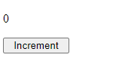

Google Chrome:

Same application was run in Google Chrome when the value in Microsoft Edge was 3. The result was:

If the application is accessed in different browsers, the value of the counter would be completely different because the view state does not preserve the value across the different sessions as each session would have its own view state.

**Problem 2)**

Extend the program implemented above and make the View State secure? Refer to Page 247 of the textbook for the technique of securing?

**Problem 3)** Implement the “Retaining Member Variables” example given at Page 249 in the textbook?

**Problem 4)** Consider the following definition of customer class. Develop a web form that stores three objects of customer in view state. Implement the code for retrieving customer objects also?

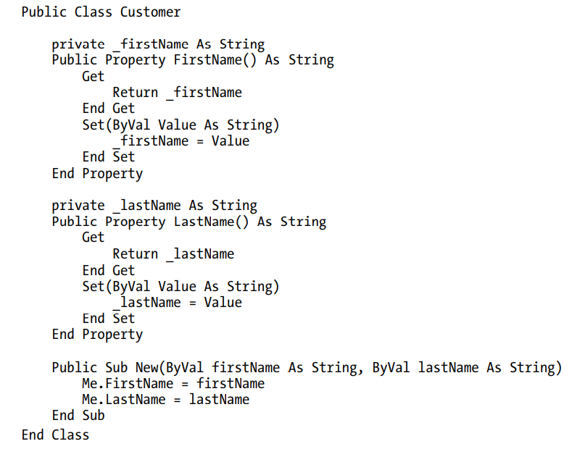

Front End Code:

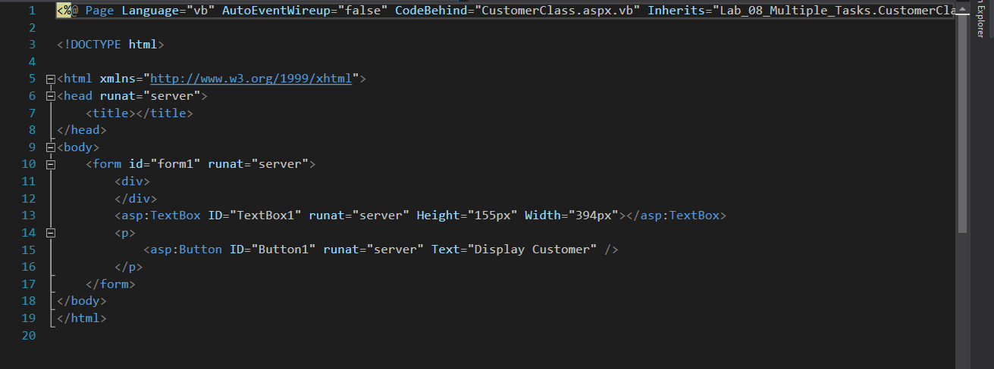

Back End Code:

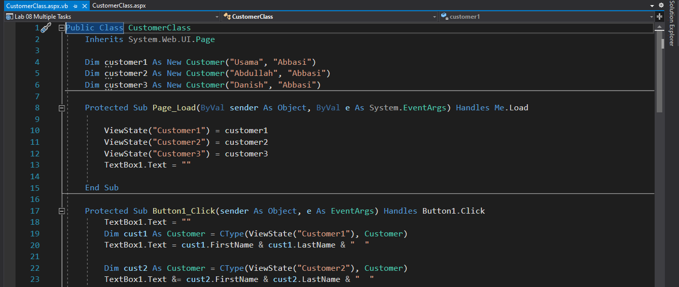

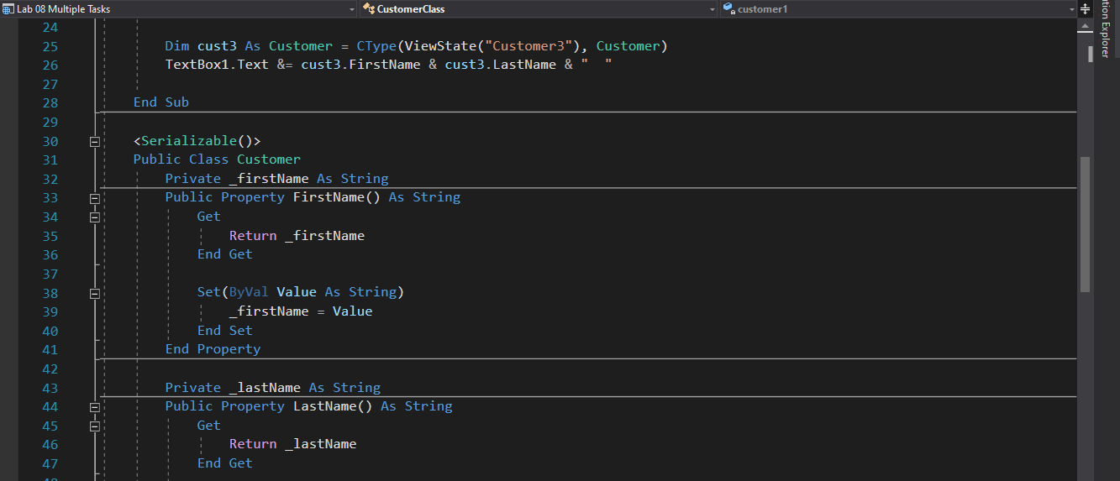

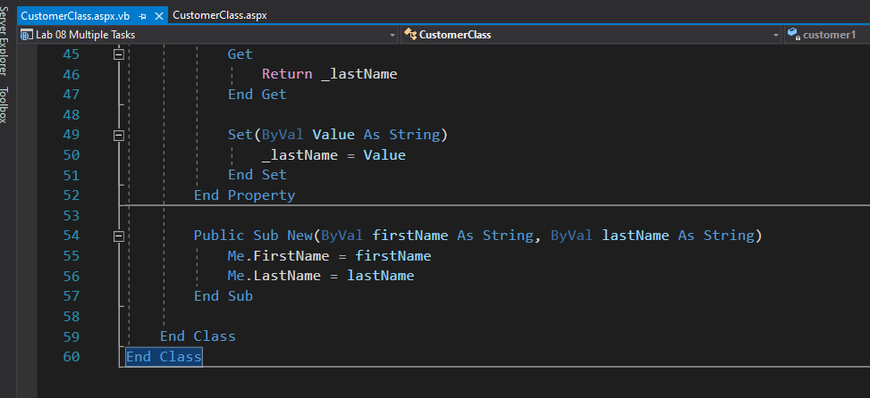

Output:

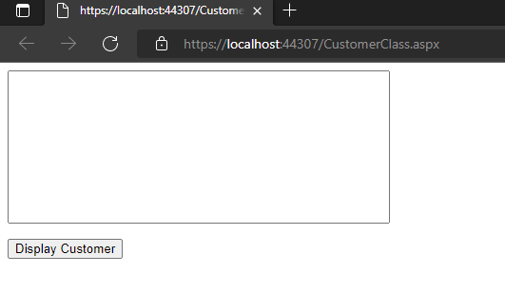

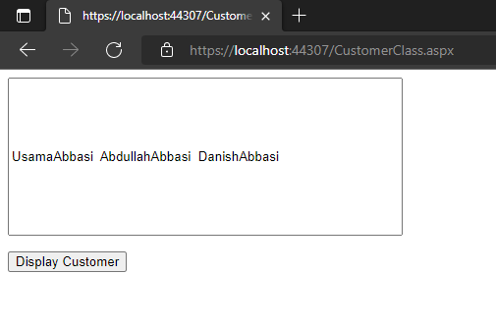

**Problem 5)** Develop a page for storing and retrieving a value “43854” of a variable “W” using hidden form field? Is it possible to alter W at client end? Try to implement a code for altering W at client end?

Front End Code:

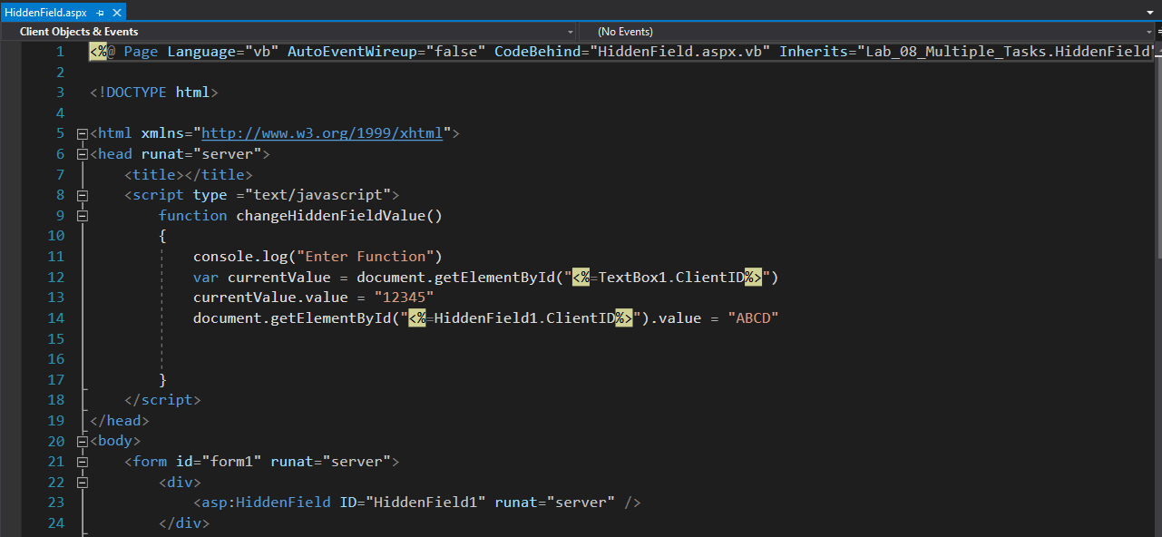

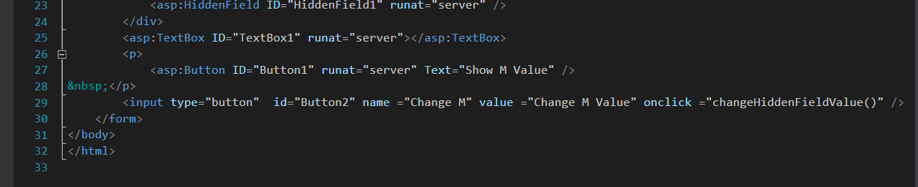

Back End Code:

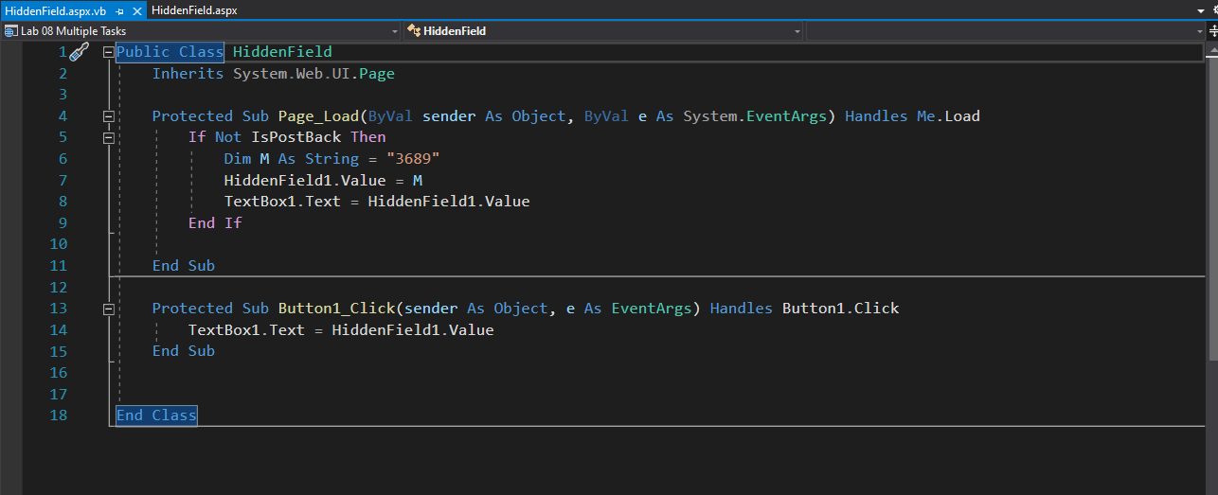

Output:

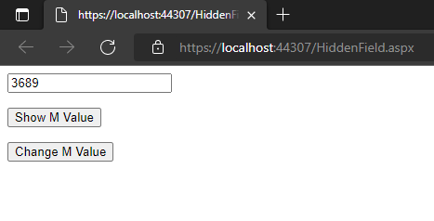

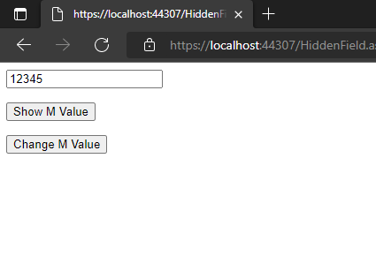

**Problem 6)** Develop a web form having a list box filled with customer names. Fill customer names in text and customer id in value properties of list items. Try to transfer the selection of list item made by user to another page using query string. Add a few more web controls on web form. Extend your code to transfer all selected/entered values to a second web form using query string.

Front End Code:

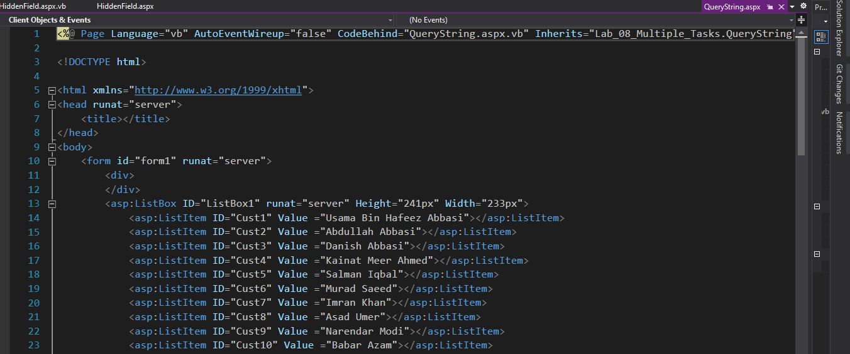

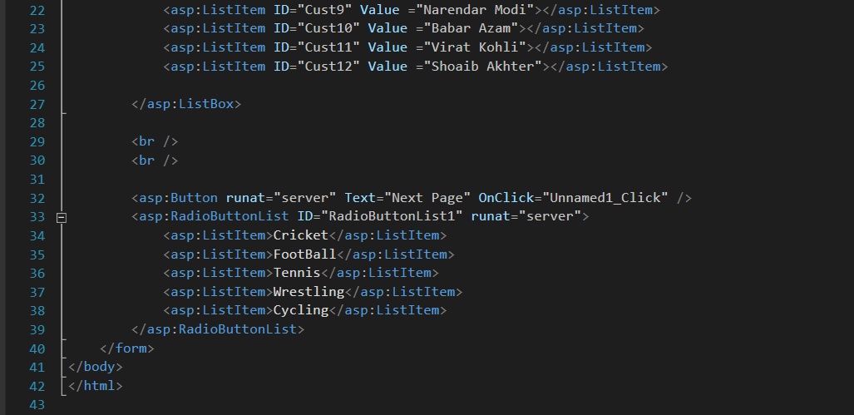

Back End Code:

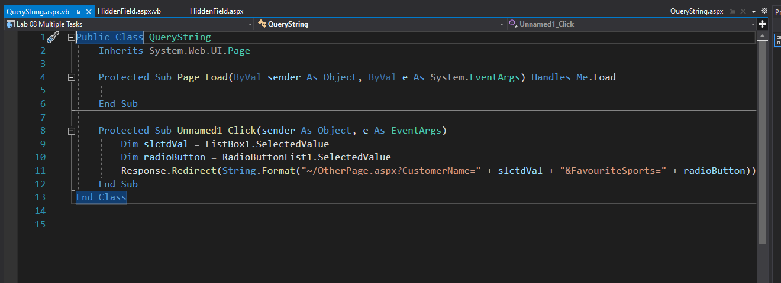

Output:

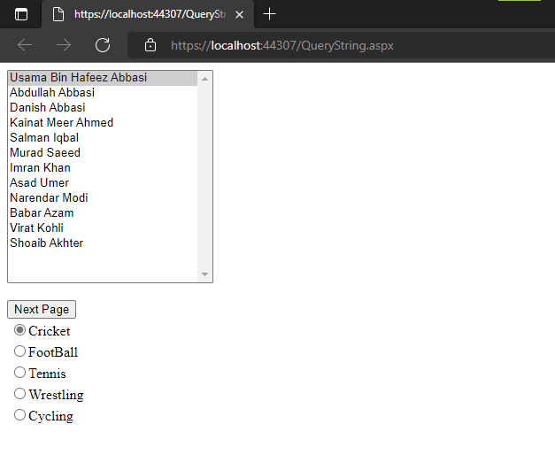

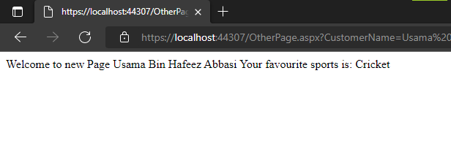

**Problem 7)** Develop a web form that implements the following scenario:

Upon first time access of page by customer a cookie is stored in user browser (make it persistent). Within the cookie store customer name and date and time values. When the customer revisits the same page and the cookie is found, retrieve the stored values and display on the page.

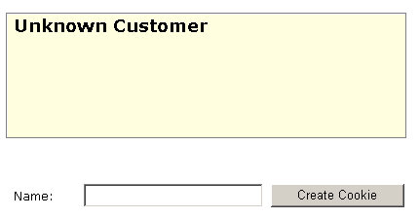

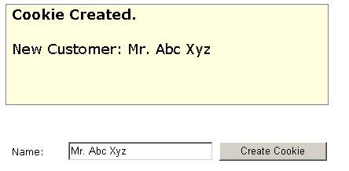

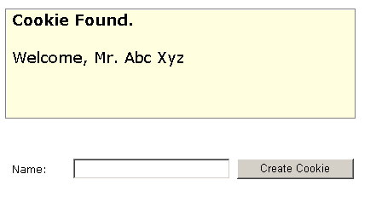

**Note:** *In real world applications we never assign the button name as “Create Cookie”*

Front End Code:

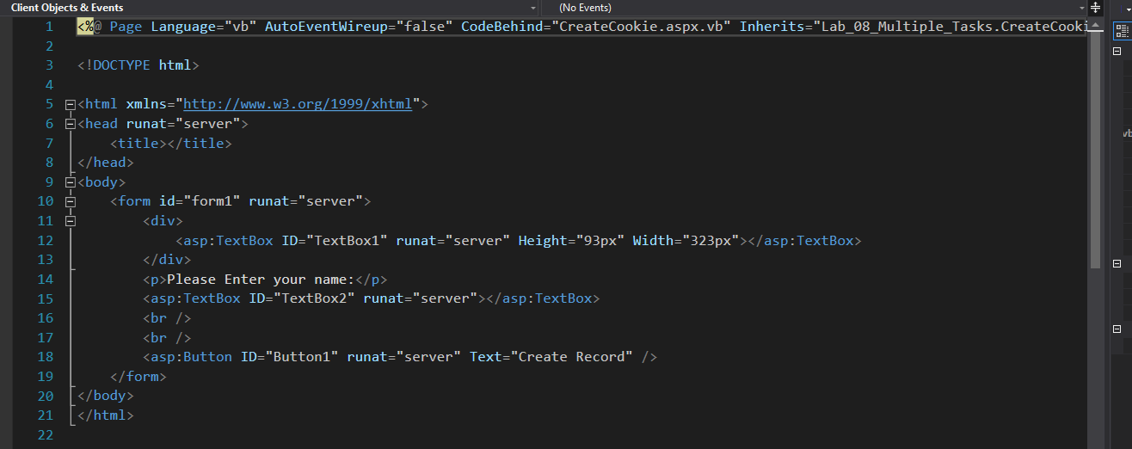

Back End Code:

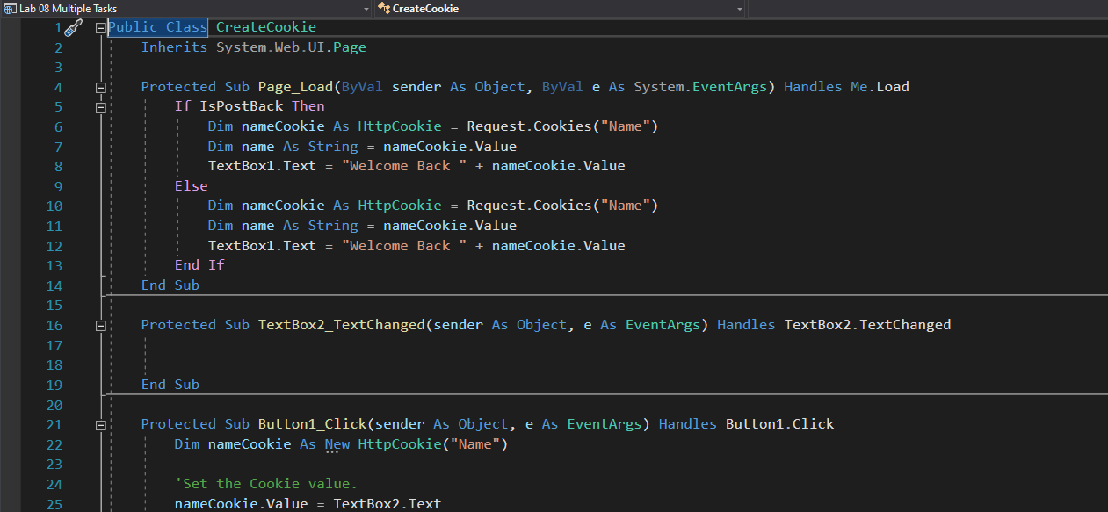

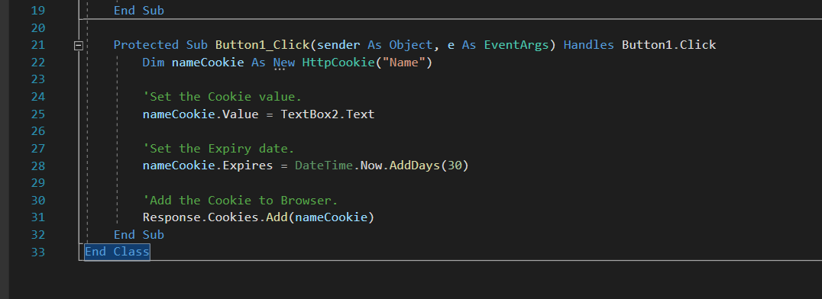

Output:

